Answer the following questions about climate change using the links provided and scientifically sound sources! First, review this NASA web page for kids:

Meet the Greenhouse Gases!

1. According to scientists, what are the six gases that are responsible for the greenhouse effect? For each gas, name a human activity that is adding it to the atmosphere.

Greenhouse Gas | Human activity generating this gas

Next, look at this feature:

Seven Things to Know About Climate Change

2. According to this website, what are seven things that we should know about climate change? For each of these items of information, what effect do you think they might have on your future?

Thing to know | Effect on your future

Then, explore the solutions proposed on this website:

5 Ways to Curb Climate Change

3. For each category listed on the website, pick one action that you think is the best idea for people to curb (or slow down) global warming. Why did you pick this action?

Category | Action | Why is this the best idea?
You
Businesses
Cities
Nations
World

Answer these questions:

4. Look at the list of “Global Warming & Climate Change Myths” from SkepticalScience.com. Pick an argument that you’ve heard before or wondered about before, and read the scientific evidence that disputes the argument. Which argument did you pick, and why? Do you think the scientific evidence completely dispels the myth? Why or why not?

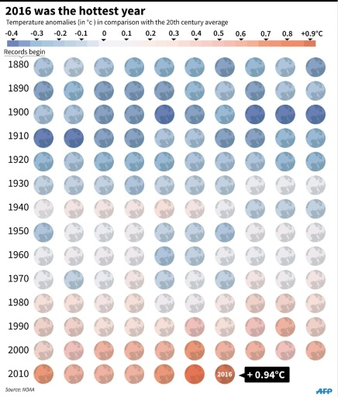
5. According to this 2010 article in The Atlantic, "the National Oceanic and Atmospheric Administration and NASA's Goddard Institute for Space Studies announced that 2010 had registered as the hottest year on record." Then, another article from the NOAA says that 2012 was the warmest year on record for the United States. Recently, NASA declared 2016 the hottest year on record, and then NOAA said that 2017 was the third hottest year ever. This pattern of warming is shown in the graphic to the right, and you can also see it in this incredible animation from Bloomberg.

Despite all of this scientific information, only 57% of Americans currently believe global warming is caused by human activities. Why do you think it isn’t 100%?

Finally, take this online “quiz”:

Global Warming Quiz

6. How did you do on the “quiz”? Name one item in the quiz that you found interesting and explain why.

