Unit 1 Test Review

Macromolecule | Function | Monomer | Polymer | Examples | Structure
Carbohydrates
-OSE

Lipids

Proteins
-ASE
-Enzyme

Nucleic Acids

- Match the following characteristics to prokaryotes, eukaryotes, or both.

___bacteria A. Prokaryotes
___amoeba B. Eukaryotes
___reproduce asexually C. Both
___larger
___membrane bound organelles
___contain ribosomes
___true nucleus
___contain a cell membrane
___only contains one cell
___evolved over time from the other type
- Wednesday, after practice, Charlie decides that in order to physically prepare for the football game against LaGrange on Friday, he needs to monitor the food that he eats. Since he knows that he will be playing the entire game, he will need something that provides lots of stamina. LHS has some large players, so he thinks that increased muscle mass will also be beneficial. Which macromolecules should he make sure that he is getting through his food, and why?

What are some examples of the foods that he should eat?

On Friday, which macromolecule(s) will help him do his best during the entire game and why?

- You are reviewing with your study partner, Errin, for the Biology test on Friday. Errin tells you that enzymes raise the activation energy for a reaction to occur. He says that enzymes are nucleic acids that join with products to create a substrate and speed up a reaction. Is Errin correct? What would you say in response?

- Phillip analyzes a graph with two curves, one (A) directly above the other (B). The y-axis is labeled with “energy” and the x-axis is labeled with “time.” Phillip determines that curve A’s data provides evidence for the use of an enzyme. Is Phillip correct? How do you know?

- Draw a graph describing an enzyme and the activation energy.

- Label the enzymes, substrate/reactant, product, and the active site.
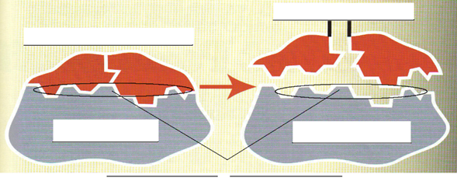

- People who are lactose intolerant lack the enzymes to break down the sugar in milk called lactose. They have many enzymes in their stomachs that can break down other substances like lipids, and proteins – why can’t these enzymes just break down the lactose too?

- What 2 words both mean “something that speeds up chemical reactions?”

- Will you study for this test? If so, explain how (ie. Your study skills)?

