The Genetically Modified Organism (GMO) Debate

Understanding the Issue
The use of Genetically Modified Organism (GMOs) in agriculture has become an incredibly contentious issue over the last several years. In order to form an opinion on the use of the technology, the first step is to understand it.

Watch the episode of the BBC Horizon television series Jimmy’s GM Food Fight. In the table below, list any potential concerns or drawbacks of planting genetically modified crops as well as possible applications and benefits of the technology. Finally, give a brief description of how the plants are developed.

How the Process Works – You will find the answer to this during the part of the video when Jimmy is working with the scientist to create the GM plant. The video will show a diagram with a short description of how they create GMO’s. Write down the process below:

Examples of Genetically Modified Plants – Jimmy’s GMO Food Fight will also provide examples of genetically modified plants/foods. Provide examples below:

Benefits of the Technology | Issues or Problems with the Technology

The Issue: Should GMOs be Labeled?
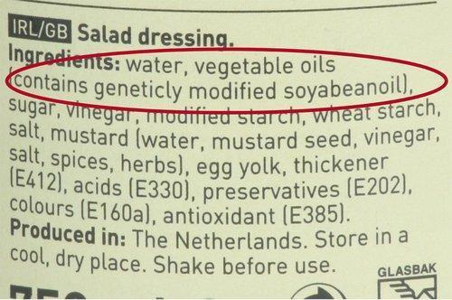
One of the biggest fights currently is whether or not genetically modified organisms should be labeled in the United States. In the European Union, all genetically modified food products are labeled. As a result, many consumers simply will not buy them.

Labeling of GMO foods currently does not occur in the United States. This issue has reached the ballot of many states, with varying results.

Editorial: Labels For GMOs Are a Bad Idea

Follow the link below to read the editorial and list and briefly summarize the arguments made against labeling. Make sure you read both pages.

Original: scientificamerican.com/article.cfm?id=labels-for-gmo-foods-are-a-bad-idea
Type in this link to save time: goo.gl/Tobcwe

List of arguments made AGAINST labeling foods containing GMO’s

Editorial: 5 Reasons to Get on the Soapbox for GMO Labeling

Follow the link below to read the editorial that was written by David Bronner, president of Dr. Bronner’s Magic Soaps and a major contributor to GMO labeling campaigns. List and briefly summarize the arguments in favor of labeling.

Original: huffingtonpost.com/david-bronner/five-reasons-to-get-on-the-soapbox_b_4183815.html
Type in this link to save time: goo.gl/qezqM3

List of arguments FOR labeling foods containing GMO’s

Essay

Your assignment will be to type a 2-3 page essay on the issue of GMO labeling. Your essay should have the following format:

- Double spaced with a font size of 12

Use the following resources to help write your essay:

- Notes from Jimmy’s GMO Food Fight movie
- Notes from article against GMO labeling
- Notes from article for GMO labeling

Your essay should be organized into the three following parts:

- Introduction
- Explain what a genetically modified organism is.
- How is the gene inserted into the organism?
- Describe two examples of genetically modified foods that are widely available in the U.S.
- What are some benefits of growing GMO crops?
- What are the environmental and health concerns of growing GMO crops?

- Benefits and Drawbacks of GMO Labeling
- Describe any reasons why consumers would want GMO labeling.
- Why has GMO labeling been resisted by the government and industry?

- Conclusion
- Explain your stance on the issue. What do you feel are the most compelling arguments, and why?
- How do you think the public would react to seeing these labels? Would they avoid purchasing genetically modified foods, like in many European countries?
- If GMOs were labeled, would you make any attempt to avoid foods that contained them? Why, or why not?

When you finish your essay be sure to grade your own work using the rubric. After you have graded your own essay, you will turn in the following for a summative grade:

- Essay will be turned in electronically.
- Rubric where you have graded your own work will be SENT in to me
  - Your grade on your rubric will count as 5 points of the total points for the project.
    - Total points for project = 105 points

